**PRACTICAL NO 10**

**Aim : Practical of Decision Tree**

mydata<-data.frame(iris)

attach(mydata)

install.packages("rpart")

library(rpart)

model<-rpart(Species~Sepal.Length+Sepal.Width+Petal.Length+Petal.Width,data=mydata,

method="class")

plot(model)

text(model,use.n=TRUE,all=TRUE,cex=0.8)

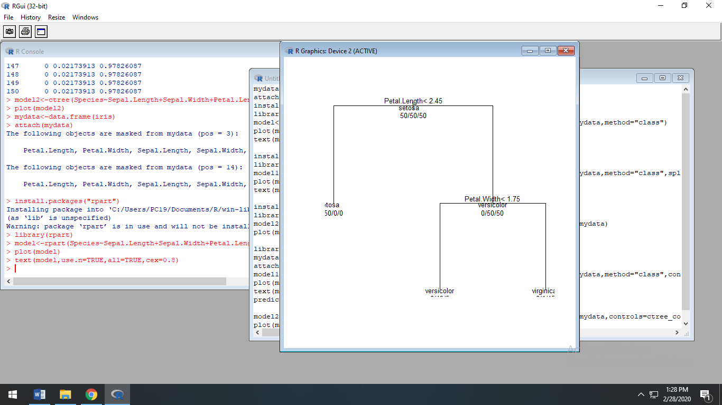

install.packages("tree")

library(tree)

model1<-tree(Species~Sepal.Length+Sepal.Width+Petal.Length+Petal.Width,data=mydata,method="class",split="gini")

plot(model1)

text(model1,all=TRUE,cex=0.6)

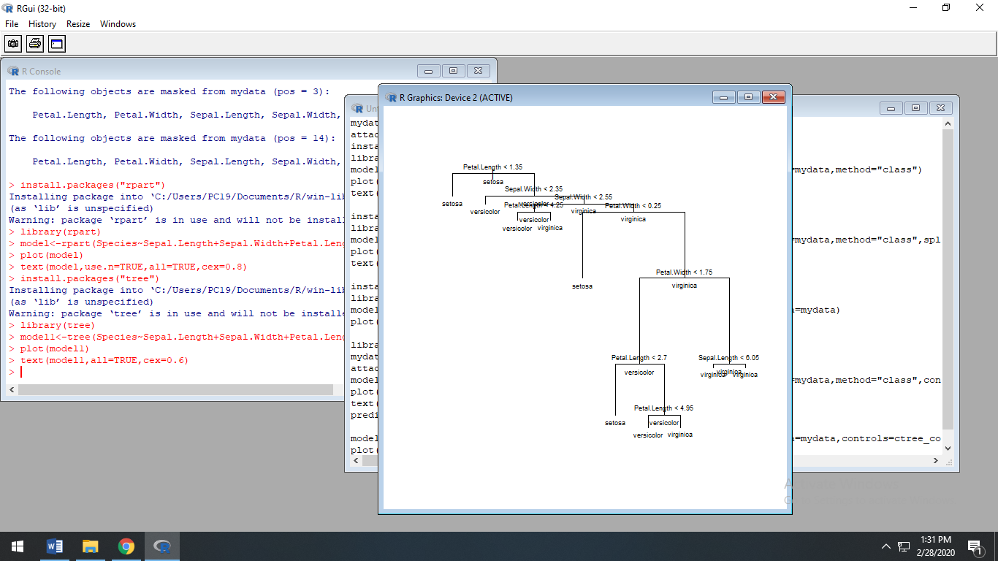

install.packages("party")

library(party)

model2<-ctree(Species~Sepal.Length+Sepal.Width+Petal.Length+Petal.Width,data=mydata)

plot(model2)

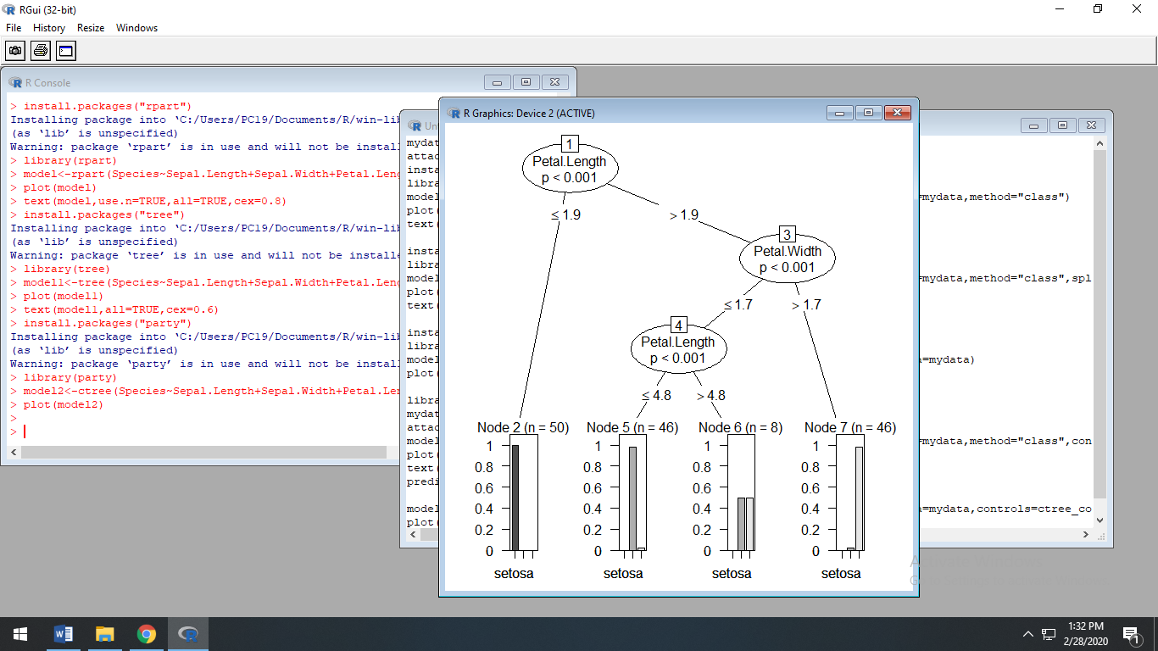

library(tree)

mydata<-data.frame(iris)

attach(mydata)

model1<-tree(Species~Sepal.Length+Sepal.Width+Petal.Length+Petal.Width,data=mydata,method="class",control=tree.control(nobs=150,mincut=10))

plot(model1)

text(model1,all=TRUE,cex=0.6)

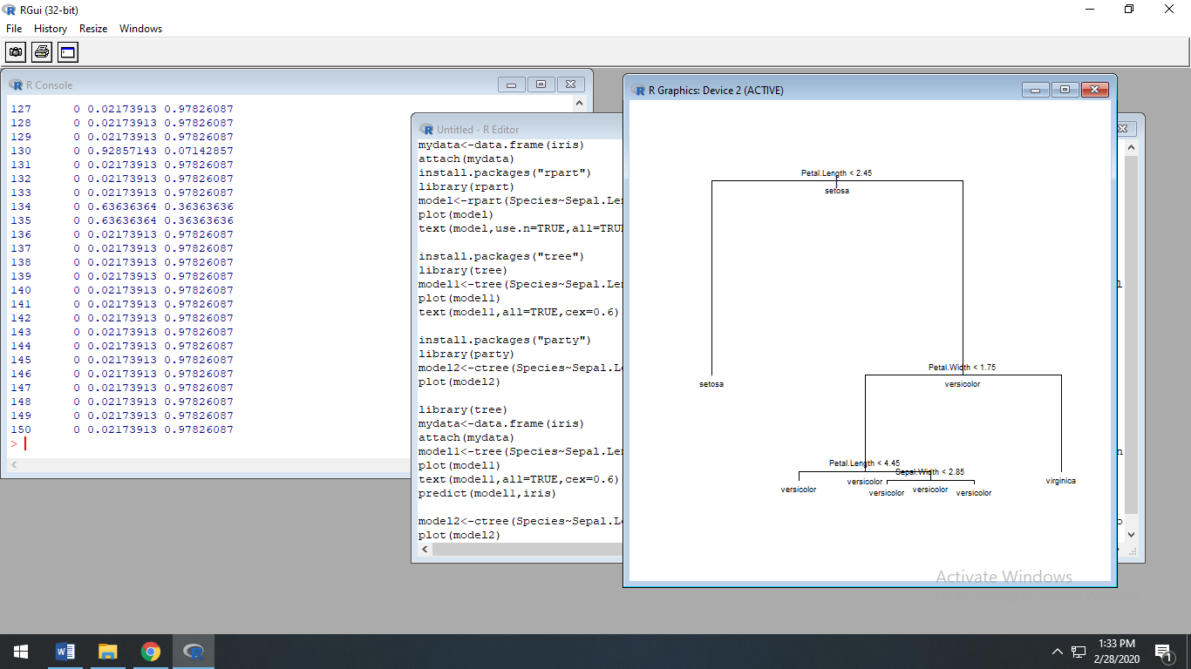

predict(model1,iris)

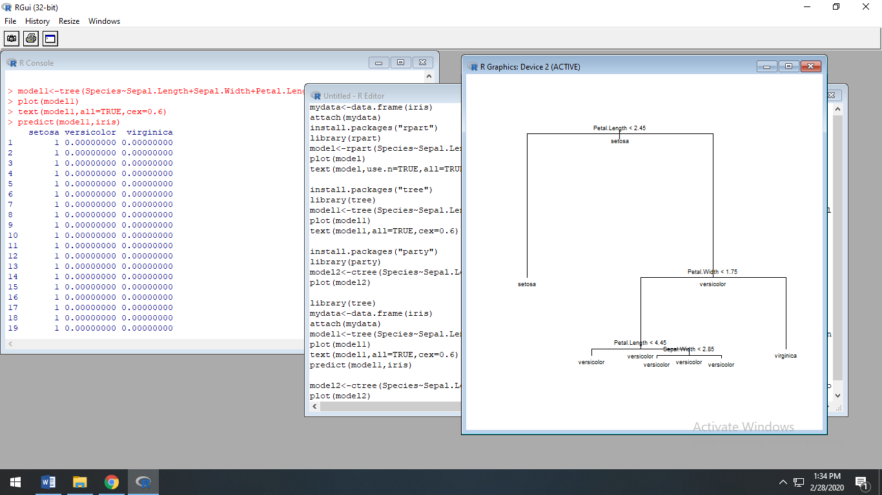

model2<-ctree(Species~Sepal.Length+Sepal.Width+Petal.Length+Petal.Width,data=mydata,

controls=ctree_control(maxdepth=2))

plot(model2)

